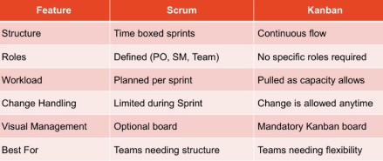
Project: a temporary effort/work undertaken to create a unique product, service, or result. Difficulty: uncertainty, hidden complexity. Failed Reason: requirement change, underestimated complexity, misalignment between business and technical teams. Core PM skill (Planning management)+Soft skill (communication). Success means stakeholders satisfaction, align with strategic goals, team performance.
Triple Constraints: Scope↑→Time/Cost↓; Time↓→Cost↑/Scope↓；Budget↓→ Scope↓
Project Management (delivering a specific output) → Program Management (collection of related projects, deliver business value which could not get by managing them individually) → Portfolio Management (collection of programs and projects, alignment with organizational strategy)
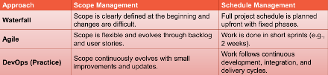
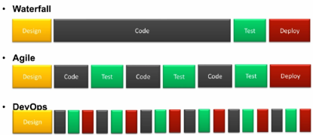
Project Lifecycle is the structured sequence of phases a project goes through from start to finish. Execution has the biggest influence. Ensure consistency and predictability+Improve team collaboration+Manage risks, time, and costs+Align work with business goals. Initiation defines the project and evaluates feasibility for formal approval, include stakeholder identification, Expert Judgement, SWOT. Planning builds a comprehensive guide plan, outputting the approved Project Management Plan. Execution performs the actual work to develop and review project deliverables. Monitoring & Controlling tracks performance to issue status reports and required course corrections. Closure wraps up the project to deliver results, yielding the final report, lessons learned, and official client sign-off.
Waterfall: linear, each phase must be completed before the next begins, not change, many documentation, not contact with customer. Simple+Clear milestone VS Not flexible+Not fit dynamic
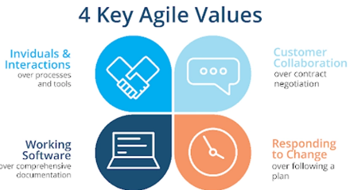
Agile: not a management technique but a mindset, release by features. Only include Dev parts
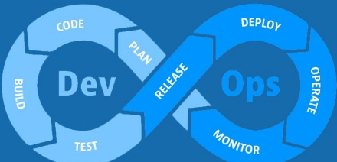
DevOps: It is a culture. A set of practices that integrates software development and IT operations to shorten the development lifecycle, increase deployment frequency, and deliver high-quality software continuously. Build means integrate the code. Automation enforces behavior at scale. CI: Auto build and test tools such as Jenkins. Continuous Delivery：ensuring the software is always in a releasable state. Continuous Deployment: your production pipeline is released to your customers‘ environment automatically.
Scrum VS Kanban (Both belong to Agile)
Scrum: Sprint,Product Backlog,Sprint Backlog,Increment
Kanban: continuous delivery, limiting work in progress (WIP), and workflow transparency.
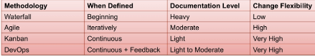
Requirement Gathering: Ensures the final product meets stakeholder needs; Reduces scope creep and rework; Forms the foundation for design, development, and testing; Facilitates better project planning and estimation. Methods: Interviews, Surveys, Workshops, Observation, Document Analysis.
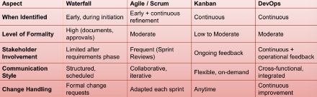
Identify Stakeholder: All identified in early stage, but style and frequency is different. Stakeholder is anyone who impacts or is impacted by the project: positively or negatively. Key activities: Identify, Analyze, Prioritize, Engage, Monitor Engage.
Project Charter: a formal document that authorizes the project and grants the project manager the authority to use organizational resources. Includes: Project title+end date+brief background. Purpose: Establishes a clear vision of the project+Aligns stakeholders and secures executive support+Provides a high-level roadmap for planning+Act as a reference point for project.
Interest/Power Grid: HP-HI (Manage Closely) Project Sponsors who possess major authority and high investment, requiring continuous, intensive management; HP-LI (Keep Satisfied) individuals, such as Legal Compliance Officers, hold significant power but low daily interest, meaning they must be kept satisfied with high-level updates to prevent roadblocks; LP-HI (Keep Informed), including End-users, lack direct authority but care deeply about outcomes, making regular information sharing essential to leverage them as project advocates; LP-LI (Monitor) like General Suppliers, require minimal effort and should simply be tracked through low-frequency, routine communication.
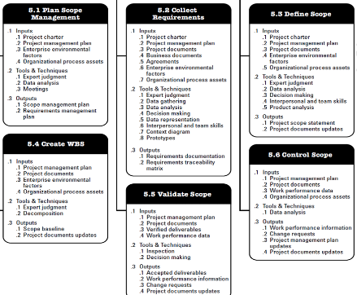
1 Scope Management: defines how the project scope will be defined, validated, and controlled. A WBS item is the responsibility of only one individual, even though many people may be working on it. Analogous (Review WBS of similar projects and tailor to your project),Top-Down,Bottom-Up,Mind-mapping. Issues: Scope Creeps(Uncontrolled changes or continuous growth in a project's scope without adjustments to time, cost, and resources), Miscommunication,Overambitious Scope.
2 Schedule Management: the process of planning, developing, managing, executing, and controlling a project’s schedule so that it can be completed within the agreed time frame.
2 means break down work packages from the Work Breakdown Structure (WBS) into specific, manageable tasks.
3.1 Types of dependencies: Mandatory(cannot be changed, Hard logic), Discretionary(based on best practices), External(rely on activities outside the project team’s control. Example, Governance approvement), Internal(within the project team’s control;
3.2 AON Activity on nodes, arrow show dependencies; AOA Activity on arrows, nodes show events.
3.3 Precedence Diagramming Method PDM: a Type of AON;
Finish to Start (FS) - Activity B starts after A finishes (most common).
Start to Start (SS) - Activity B starts when A starts, namely, B cannot start until A start.
Finish to Finish (FF) - Activity B finishes when A finishes, namely, B cannot finish until A finish.
Start to Finish (SF) - Activity B finishes when A starts (rare). B cannot finish until A start.
3.4 Lead time：start next task earlier, Overlap between tasks. It accelerates the schedule.
3.5 Lag time：delay next task. It inserts a waiting period.
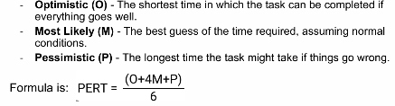
4.1 Three Point Estimate - PERT
4.2 Analogous Estimating: top-down, based on historical data, fast, less cost, but require experts
4.3 Parametric Estimating: Require relationship between variables are consistent and scalable.
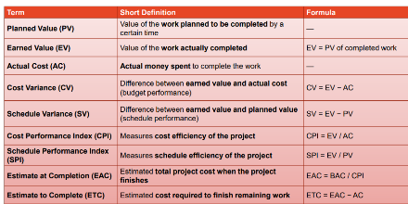
5.1 Gantt Chart: A horizontal bar chart; Visualizing the project timeline; Tracking progress against the baseline schedule; Identifying overlaps, leads, and lags; length represents its duration.
5.2 Critical Path Method: identify the longest sequence of dependent activities in a project. Any delay on the Critical Path will DELAY the entire project.
6.1 Fast Tracking Perform activities in parallel that were originally sequential. Increases risk but shortens schedule.
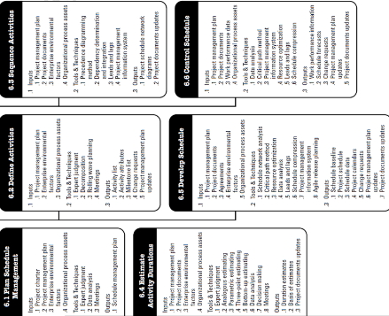
6.2 Crashing Add more resources to critical path activities to finish sooner. Increases cost, may increase risk.
3 Cost Management: process of estimating, budgeting, and controlling costs. Why Critical: Rapidly changing technology, volatile pricing, Hidden costs (integration, security, compliance), Vendor lock-in & license renewals. Challenges: Hidden and recurring costs, Measurement challenges.
Type of Cost: Tangible: Costs that an organization can easily measure in dollars (e.g., hardware purchases, software licenses, and team salaries). Intangible: Costs that are difficult to measure in monetary terms (e.g., impact on employee morale, loss of customer goodwill, or brand reputation). Direct: Costs that are directly related to producing the products and services of the project (e.g., project team travel expenses, project-specific materials). Indirect: Costs that are not directly related to the specific products or services but are indirectly related to performing the project (e.g., office rent, utilities, and general administrative support). Sunk: Money that has been spent in the past when deciding what projects to invest in. According to PMP standards, sunk costs are not included in the decision-making process for future project investments or current performance measurement.
Contingency Reserves: Funds for "known-unknowns" (partially planned situations). These are included in the cost baseline. Usually take 10% of total cost.
Management Reserves: Funds for "unknown-unknowns" (unpredictable situations). These are not included in the cost baseline.
1 Purpose: Ensures consistency, Provides guidelines for resource allocation and budget approvals, Helps prevent budget overruns.
2 Analogous, Parametric, Bottom-Up(most detailed), Three-Point, Expert Judgment
Benchmark: Using historical project data or industry averages to guide cost estimation.
Budget = Cost Estimates + Contingency Reserves + Management Reserves
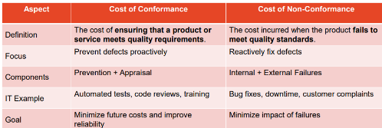
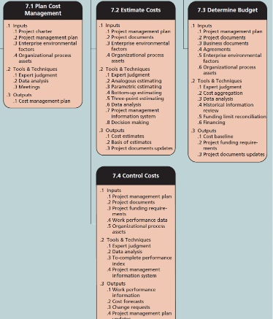
Cost Baseline: time-phased budget; includes direct costs, indirect costs, and contingency reserves, No management reserves
4. Earned Value Management EVM：a methodology that integrates scope, schedule, and cost to objectively measure project performance and progress.
SV is Positive → ahead of schedule; Negative → behind schedule
CPI > 1 → cost efficient; CPI < 1 → cost overrun
SPI > 1 → ahead of schedule, efficient; SPI < 1 → behind schedule
Challenges of Applying EVM in Agile Projects: Changing scope makes Planned Value unstable; Story points and features are not directly measurable in dollars; Sponsors often expect cost forecasts in monetary terms rather than velocity metrics. Solution:
Track Earned Business Value (EBV) instead of only cost efficiency, Map story points to cost using sprint burn rates, Recalculate EAC at the end of each iteration using rolling forecasts.
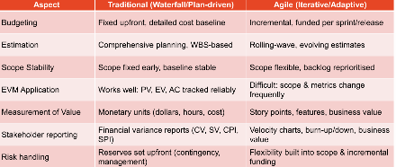
Traditional VS Agile Cost Management
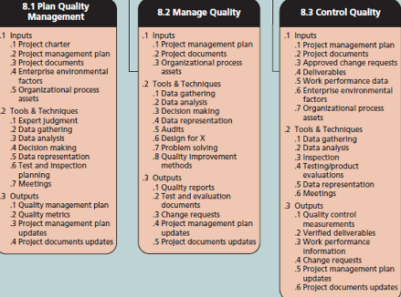
4 Quality Management: Identifying the quality requirements and standards for the project and deliverable. About both product quality and process quality.ISO9001 quality.ISO/IEC27001 Security
Major principles: Customer focus: End-user satisfaction is the ultimate quality measure. Prevention over Inspection: It’s cheaper to prevent defects than fix them later. Continuous Improvement: Using lessons learned and feedback loops (Agile, Kaizen, DevOps). Fact-based decision making: Using metrics, dashboards, and data analysis.
Project Manager: need to Monitors CoQ (Cost of Quality), CoC (Cost of Conformance), and CoNC (Cost of Non-Conformance)；CoQ=CoC+CoNC
Quality Assurance Team: Define processes, methods, and metrics.
Quality Control Team: Execute tests
Development Team: Follow coding standards, guidelines, and defined processes.
Agile Based QMP: Focuses on delivering quality incrementally.
DevOps based QMP: Focuses on ensuring continuous quality from end-to-end. Automation every where
2.1 Focuses on preventing defects rather than just detecting them
2.2 Process Audits: check if teams are following defined quality standards, policies, and procedures. catch process issues before they lead to product defects.
2.3 Quality Assurance Reviews: the process of structured evaluations of deliverables and processes, performed throughout the project. Includes peer reviews, design walkthroughs, and retrospectives.
2.4 Continuous Process Improvements: an ongoing effort to refine processes for better efficiency, effectiveness, and adaptability. Often guided by PDCA (Plan–Do–Check–Act) or Six Sigma DMAIC.
3.1 Verification: "Did we build it right?" (meets specs).
3.2 Validation: "Did we build the right thing?" (meets user needs).
Unit testing: Tests individual components or modules of the software in isolation.
Integration testing: Tests the interaction between multiple modules or components.
System testing: Tests the complete integrated system against requirements.
User Acceptance testing: Final testing performed by end-users or clients.
Tools : Cost-Benefit Analysis, Cause and Effect Diagram, Quality Control Chart, Checksheet, Flowcharts, Scatter Diagram, Histogram, Pareto(80% of problems are caused by 20% of the causes), Lean(Focuses on eliminating waste. e.g., redundant processes, delays in defect resolution, excessive documentation), Six Sigma (Focuses on reducing variation and defects using data-driven approaches (DMAIC – Define, Measure, Analyze, Improve, Control)), Deming’s 14 Points (philosophy,Focusing on process improvement, not just inspection,provides principles and guidelines, ensure the QMP is process-focused, preventive, and continuous.), Juran’s 10 Steps(practical, Quality objectives are clear and measurable, a structured framework for ensuring that the plan is actionable, systematic, and management-led.)
Trade off: Cost vs Quality: Higher quality often requires more investment (prevention, testing, training). Cutting costs can increase defects and rework.Time vs Quality: Tight schedules may force reduced testing or shortcuts, risking quality. Extending timelines allows thorough QA but may increase costs. Scope vs Quality: Adding more features can dilute focus on quality of existing functionality.Prevention vs Quality: Investing in prevention (training, standards) reduces defects later.
CMMI Capability Maturity Model Integration: ▪Level 1: Initial - unpredictable, ad hoc. ▪ Level 2: Managed - processes are project-specific. ▪ Level 3: Defined - processes are standardized across the org. ▪ Level 4: Quantitatively Managed - metrics driven processes. ▪ Level 5: Optimizing - continuous improvement.
5 Resource Management:the process of identifying, acquiring, and managing resources.
Leadership → Inspiring, motivating, enabling collaboration. Autocratic (Directive): Leader makes decisions unilaterally. Pros: Fast decision-making, useful in crises (e.g., system outage). Cons: Low motivation, stifles creativity. Democratic (Participative): Involves the team in decision-making. Pros: Encourages innovation, increases engagement. Cons: Slower decisions, risk of conflict. Laissez-faire (Hands-off): Leader provides minimal direction, gives autonomy. Pros: Works with highly skilled, self-motivated teams. Cons: Can lead to confusion or lack of coordination.
Management → Planning, organizing, controlling resources.
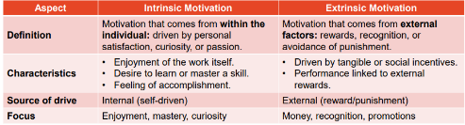
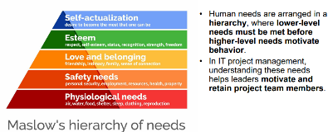
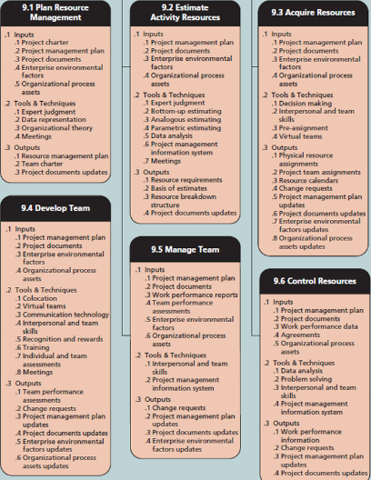
Motivation is the internal or external drive that influences people’s behavior, effort, and persistence in achieving goals.
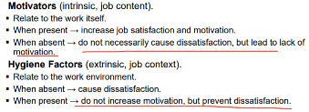
Herzberg's Motivation Hygiene Theory: Motivators: achievement, recognition, responsibility. Hygiene: Salary, working condition, Job Security.
RACI Matrix: a responsibility assignment tool that clarifies roles and responsibilities for project tasks or deliverables. Responsible: Person(s) who do the work or complete the task. Accountable: Person who is ultimately answerable; approves work and ensures task completion. Consulted: People whose input is sought before the task is done (two-way communication). Informed: People who need to be updated on progress or decisions (one-way communication.
Resource Breakdown Structure: Level 1: Broad categories of resources (Human, Equipment, Software, Materials) Level 2: Subcategories (for humans → roles; for software → tools/platforms. Level 3: Specific resources (names, tools, versions, servers, licenses)
Resource Histogram: a bar chart that shows the amount of time each resource is allocated over a period of time. X-axis: Time periods (days, weeks, months, sprints). Y-axis: Resource usage (hours, FTEs, or number of resources). Bars: Show how much of each resource is allocated in a given period.
2 Estimating Activity resources: Expert judgement, Analogous estimating, Bottom-up, Three-point estimating (PERT).
3.1 Acquiring Resources: Internal - Use existing employees or in-house resources. Familiar with company culture, faster onboarding. External - Hire new employees, contractors, or consultants. Brings specific skills, expertise, or additional capacity. Procurement - Acquire equipment, software, or services through vendors. Multi-source - Combination of internal resources, contractors, and vendors.
3.2 Resource Load = ∑ Allocated Hours/Available Hours
3.3 Resource Leveling: the process of resolving resource over-allocation by adjusting the project schedule or redistributing resources. Ensure that no resource is overburdened. Methods include delay tasks, split tasks, and reassign tasks.
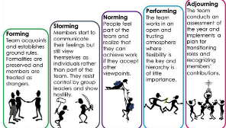
4.1 Tuckman's Model:

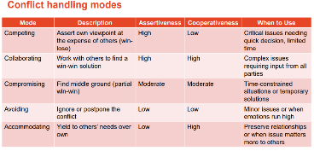
6.1 Productivity: how efficiently resources (human, equipment, or materials) are used to achieve project objectives.
6.2 Resource availability: extent to which resources (human, equipment, or materials) are accessible and ready for project tasks when needed.
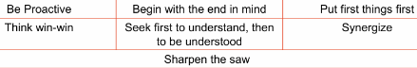
Stephen Covey’s 7 Habits provide a personal and team effectiveness framework. For HR.
6 Risk Management: Risk is about uncertainty: something that may or may not happen. Risk matters because: IT project is dynamic due to rapid change. 1plan risk management, 2identify risks, 3qualitative risk analysis, 4quantitative, 5plan risk response, 6monitor and control risk.
Goal: find risk early, minimize the risk probability, enable informed decision making under uncertainty.
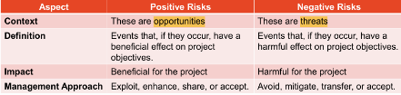
Benefits: increase the success rate, better decision making, cost and time saving.
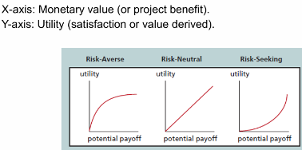
Risk Appetite: degree of uncertainty an organisation is willing to accept. risk-seeking: take bold moves to innovate. risk-averse: prioritise stability and predictability.
Risk-Neutral Culture: balances opportunities and threats pragmatically. focus only on expected monetary value EMV
2. Identify Risk tools: Brainstorming; Delphi: obtaining consensus from a panel of experts through multiple rounds of anonymous surveys; Interviewing with stakeholders; SWOT (Strength, Weakness, Opportunities, Threats): assess internal strengths & weaknesses, and external opportunities & threats, identify both positive and negative risks.
3.1 A subjective method of prioritizing risks based on their probability of occurrence and impact on objectives.
3.2 Probability Impact Matrix: A grid mapping probability vs. impact. Upper right corner is the most important risk.
4.1 A numerical, data-driven process of analyzing the effect of risks on overall project objectives (cost, schedule, scope, quality).
4.2 Monte Carlo Simulation: A probabilistic technique that uses random sampling to simulate different possible outcomes of a project.
4.3 Decision Tree Analysis: Used to calculate EMV = Posibility * Outcome (Positive means Opportunity, Negative means Threat)
5.1 Risk responses for Negative Risks: Avoidance (changing project scope), Mitigation(Reduce probability or impact; extra testing), Transfer(buy insurance), Acceptance(Do nothing proactively), Escalation(report to leader)
5.2 Risk responses for Positive Risks: Exploitation: Ensure the opportunity happens. Enhancement: Increase probability or impact, ex. team training. Sharing: Partner with a third party to capture the benefit. Such as Collaborate with another firm for joint product launch.Acceptance: Take advantage if opportunity arises but don’t actively pursue it. Escalation
5.3 Risk Register: A central document in risk management that records all identified risks, their characteristics, and planned responses. Updated throughout the project lifecycle. Ensures risks are visible, monitored, and assigned owners.
6. Traditional (Waterfall): Risks are identified, analyzed, and planned upfront during project initiation and planning. Risk register + formal reviews are created. Agile: Risks are addressed iteratively throughout the project in short cycles (sprints/iterations). Risk management is embedded in daily activities, not just upfront. Adv: Fast, adaptability to changing requirements. Iterative Risk Reviews: Risks are revisited at the end of every sprint (retrospectives).Risk-Based Backlog Prioritization: User stories and features with higher uncertainty/risk are delivered earlier (“fail fast” principle).Risk Burn-Down Charts: Similar to sprint burn-down charts but track risk exposure over time.Collaborative Ownership: Risks are not managed by a single “risk manager” but shared among the team.Hybrid: Combines structured traditional risk processes (register, probability-impact matrix) with Agile practices (daily monitoring, adaptive responses). Adv: Balances flexibility with formal governance.
7 Procurement Management:

